Jetson NX 系統燒錄與套件編譯流程

NVIDIA Jetson Xavier NX 開發板教學
https://developer.nvidia.com/embedded/learn
https://youtu.be/JgnlvQZLt9w
https://www.youtube.com/watch?v=7Cqr9R04htc
https://www.rs-online.com/designspark/jetson-nano-1-cn

直接下載映像檔進行安裝 (Windows/Mac/Linux系統電腦可用)
https://blog.cavedu.com/2020/05/15/jetson-xavier-nx-sysinstall/

在Jetson Xavier NX上以SSD運行作業系統
https://blog.cavedu.com/2020/06/02/jetson-xavier-nx-ssd/

Python virtual environment and ML platforms(Pytorch) installation
https://spyjetson.blogspot.com/2020/07/jetson-xavier-nx-python-virtual.html

Jetson Xavier NX的Torchvision報錯解決方式https://blog.csdn.net/weixin_41010198/article/details/109862917

(可選)Installing TensorFlow For Jetson Platform
https://docs.nvidia.com/deeplearning/frameworks/install-tf-jetson-platform/index.html

(可選)Installing OpenCV 4.4
https://spyjetson.blogspot.com/2020/08/jetson-xavier-nx-opencv-44.html

Cameras for Jetson Xavier NX

IMX219-120

Prices
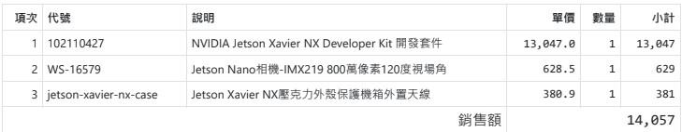

Reference
- https://github.com/ArduCAM/MIPI_Camera/tree/master/Jetson/IMX477/driver
- https://www.arducam.com/forums/forum/camera-modules-for-nvidia-jetson-nano/12mp-imx477-on-jetson-xavier-nx/
- https://www.arducam.com/docs/camera-for-jetson-nano/mipi-camera-modules-for-jetson-nano/camera-demonstration/
- https://spyjetson.blogspot.com/2020/02/camera-csi-camera-raspberry-pi-camera-v2.html

Download automatic installation script(for imx477)
https://github.com/ArduCAM/MIPI_Camera/releases/tag/v0.0.2
安裝完後重開機

Check whether the camera is detected
ls /dev/video*

Check the video format supported

Install the v4l-utils package:
sudo apt-get install v4l-utils

Determine which format and resolution the current camera supported：
v4l2-ctl --list-formats-ext

Example pipelines

1920x1080
- SENSOR_ID=0
- WIDTH=1920
- HEIGH=1080
- FRAMERATE=30
- gst-launch-1.0 nvarguscamerasrc sensor-id=$SENSOR_ID ! "video/x-raw(memory:NVMM),width=$WIDTH,height=$HEIGHT,framerate=$FRAMERATE/1" ! nvvidconv ! nvoverlaysink

Run with OpenCV
https://www.youtube.com/watch?app=desktop&v=SKailP4zKRw&feature=youtu.be

Jetson Remote
https://www.nomachine.com/

SSH
https://numato.com/blog/how-to-install-putty-on-linux/

DeepStream / NGC / Kubernetes / EGX
https://developer.nvidia.com/blog/deploying-ai-apps-with-egx-on-jetson-xavier-nx-microservers/

